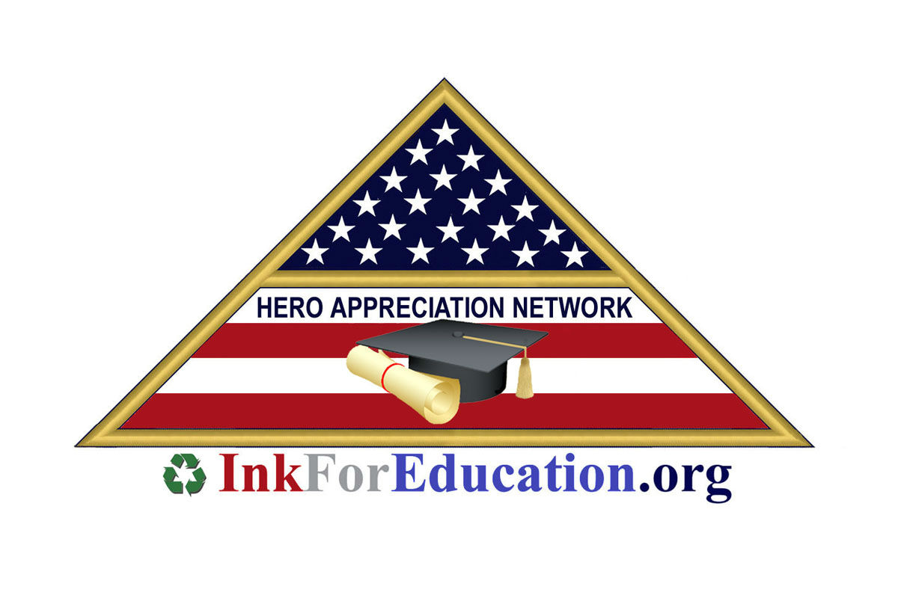
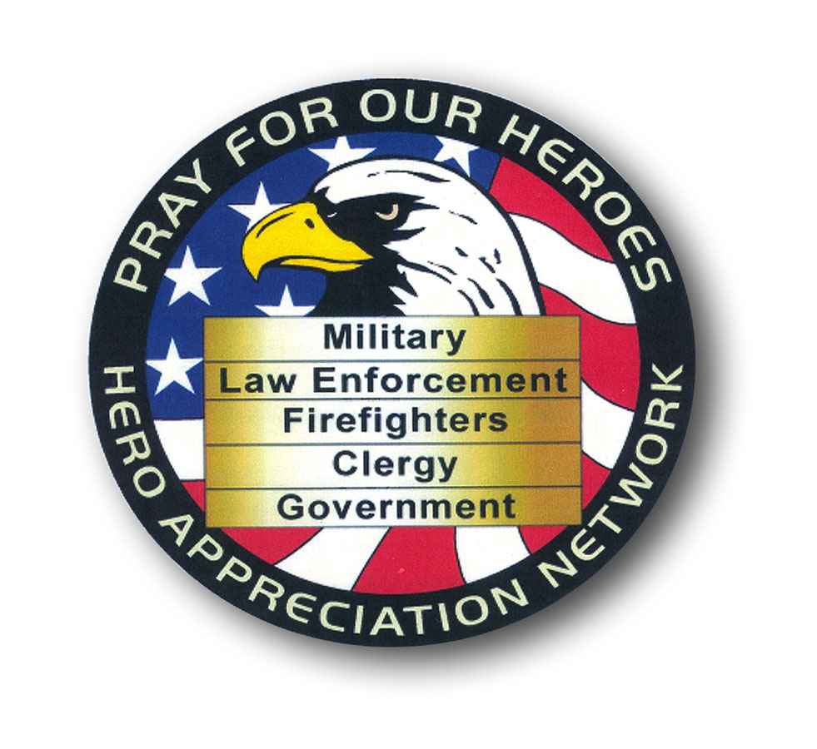

InkForEducation.org

An Introduction to the Ink For Education Program
Presented by
The Hero Appreciation Network

The Hero Appreciation Network is a 501c3 organization created to

- recognize and honor fallen heroes who have donned a uniform and served
in the ranks of our law enforcement, military, or firefighters.
- promote hope and opportunity to students and their families in paying the high cost of higher education.
- award college and vocational trade school scholarships to worthy individuals.

What is Ink For Education?

Ink for Education is a new program designed to give students, future students and alums an opportunity to receive funds for student loan debt, tuition, housing, food and books.

How? IFE collects and recycles used inkjet and toner cartridges on behalf of IFE members.

Over 700,000,000 cartridges are wasted creating an ecological hazard every year.

For every cartridge collected and donated, The Hero Appreciation Network may receive up to $3+. That means there is the potential of turning all those wasted, empty cartridges into funds approaching one billion dollars… every single year.

HOW DOES THE PROGRAM WORK?

Earning funds for college has never been easier with Ink for Education. No cost to students registering on the website (www.InkForEducation.org) where they will receive a unique Ink For Education ID# and their own account they can review online 24/7.

IFE contacts businesses and asks them to donate their empty inkjet/toner cartridges on IFE Member’s behalf.

Once the company agrees to participate in the program, they receive a certificate which grants them a tax deduction and free pick up service of their inkjet/toner cartridges.
For each cartridge that’s recycled, dollars are put into the student’s account where they can earn up to $250,000 in the program. It’s that simple!

INFRASTRUCTURE

Everything is in place and in operation. IFE has a state-of-the-art website for student registration. We have an arrangement with UPS to pick-up and transport cartridge donations at a huge 501c3 non-profit organization discount. We maintain a valuable data-base of over 2 million business contacts we send to businesses on behalf of our members. Bank of America is one of our corporate sponsors and operates all of our business and student accounts.

Why should a company agree to partner with our IFE MEMBERS?

It gets a tax deduction for the value of its cartridge donation.
It helps to keep hazardous waste material out of landfills.
It honors an American Fallen Hero.
It assists a student with his/her educational goals.
It creates American jobs in the recycling industry.
It gets recognized as a Green Company/Organization.

IN ADDITION

HAN will send to the organization that agrees to partner with one of our student members a THANK YOU letter with full information on how to arrange for free pick up or shipping.

It will receive TAX DEDUCTION RECEIPTS.

Free 5 year pick up service.

A handsome certificate recognizing it as a “Green Company.”

OUR SPONSORS
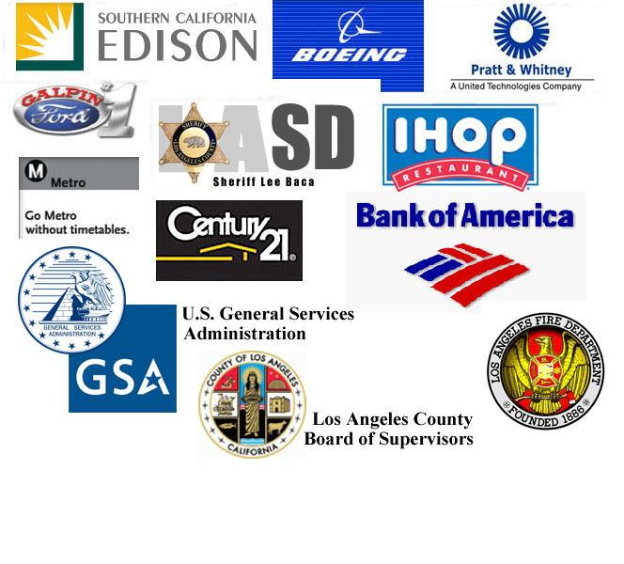

Here are only a few of
our corporate and
government sponsors.

Samples of materials sent to new business partners.
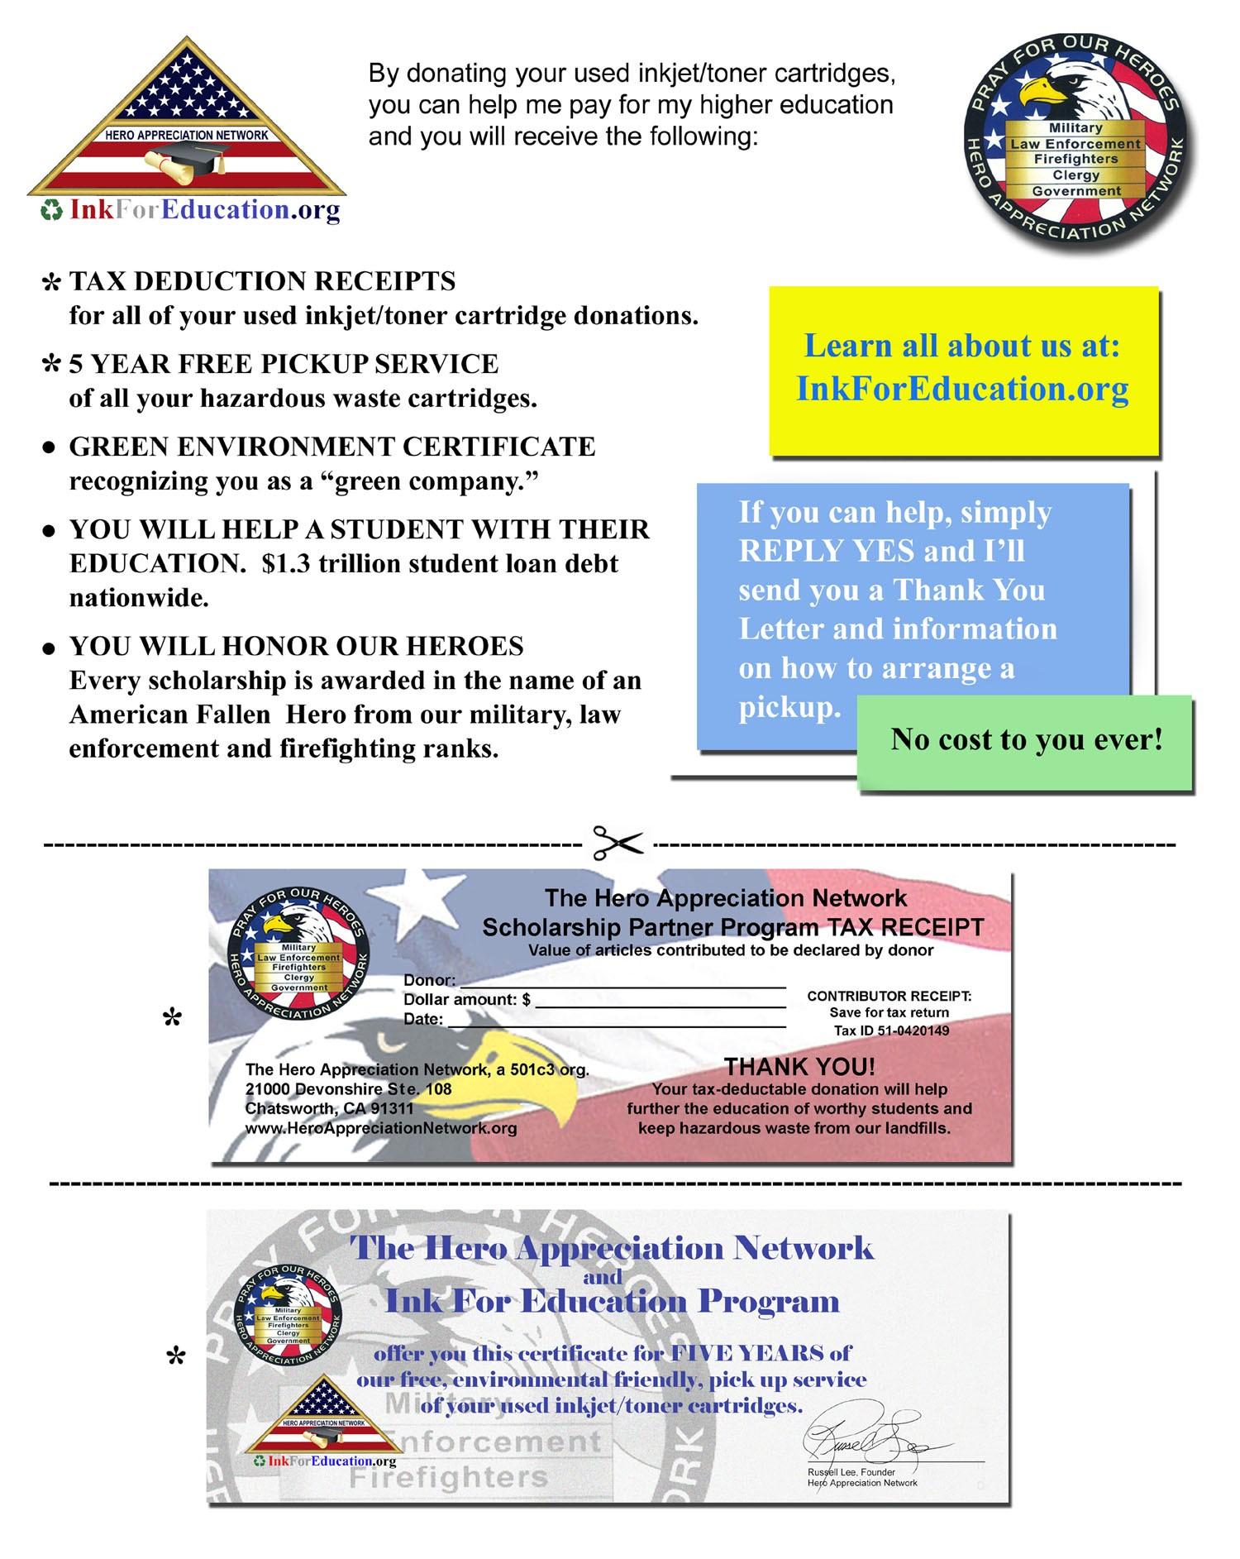

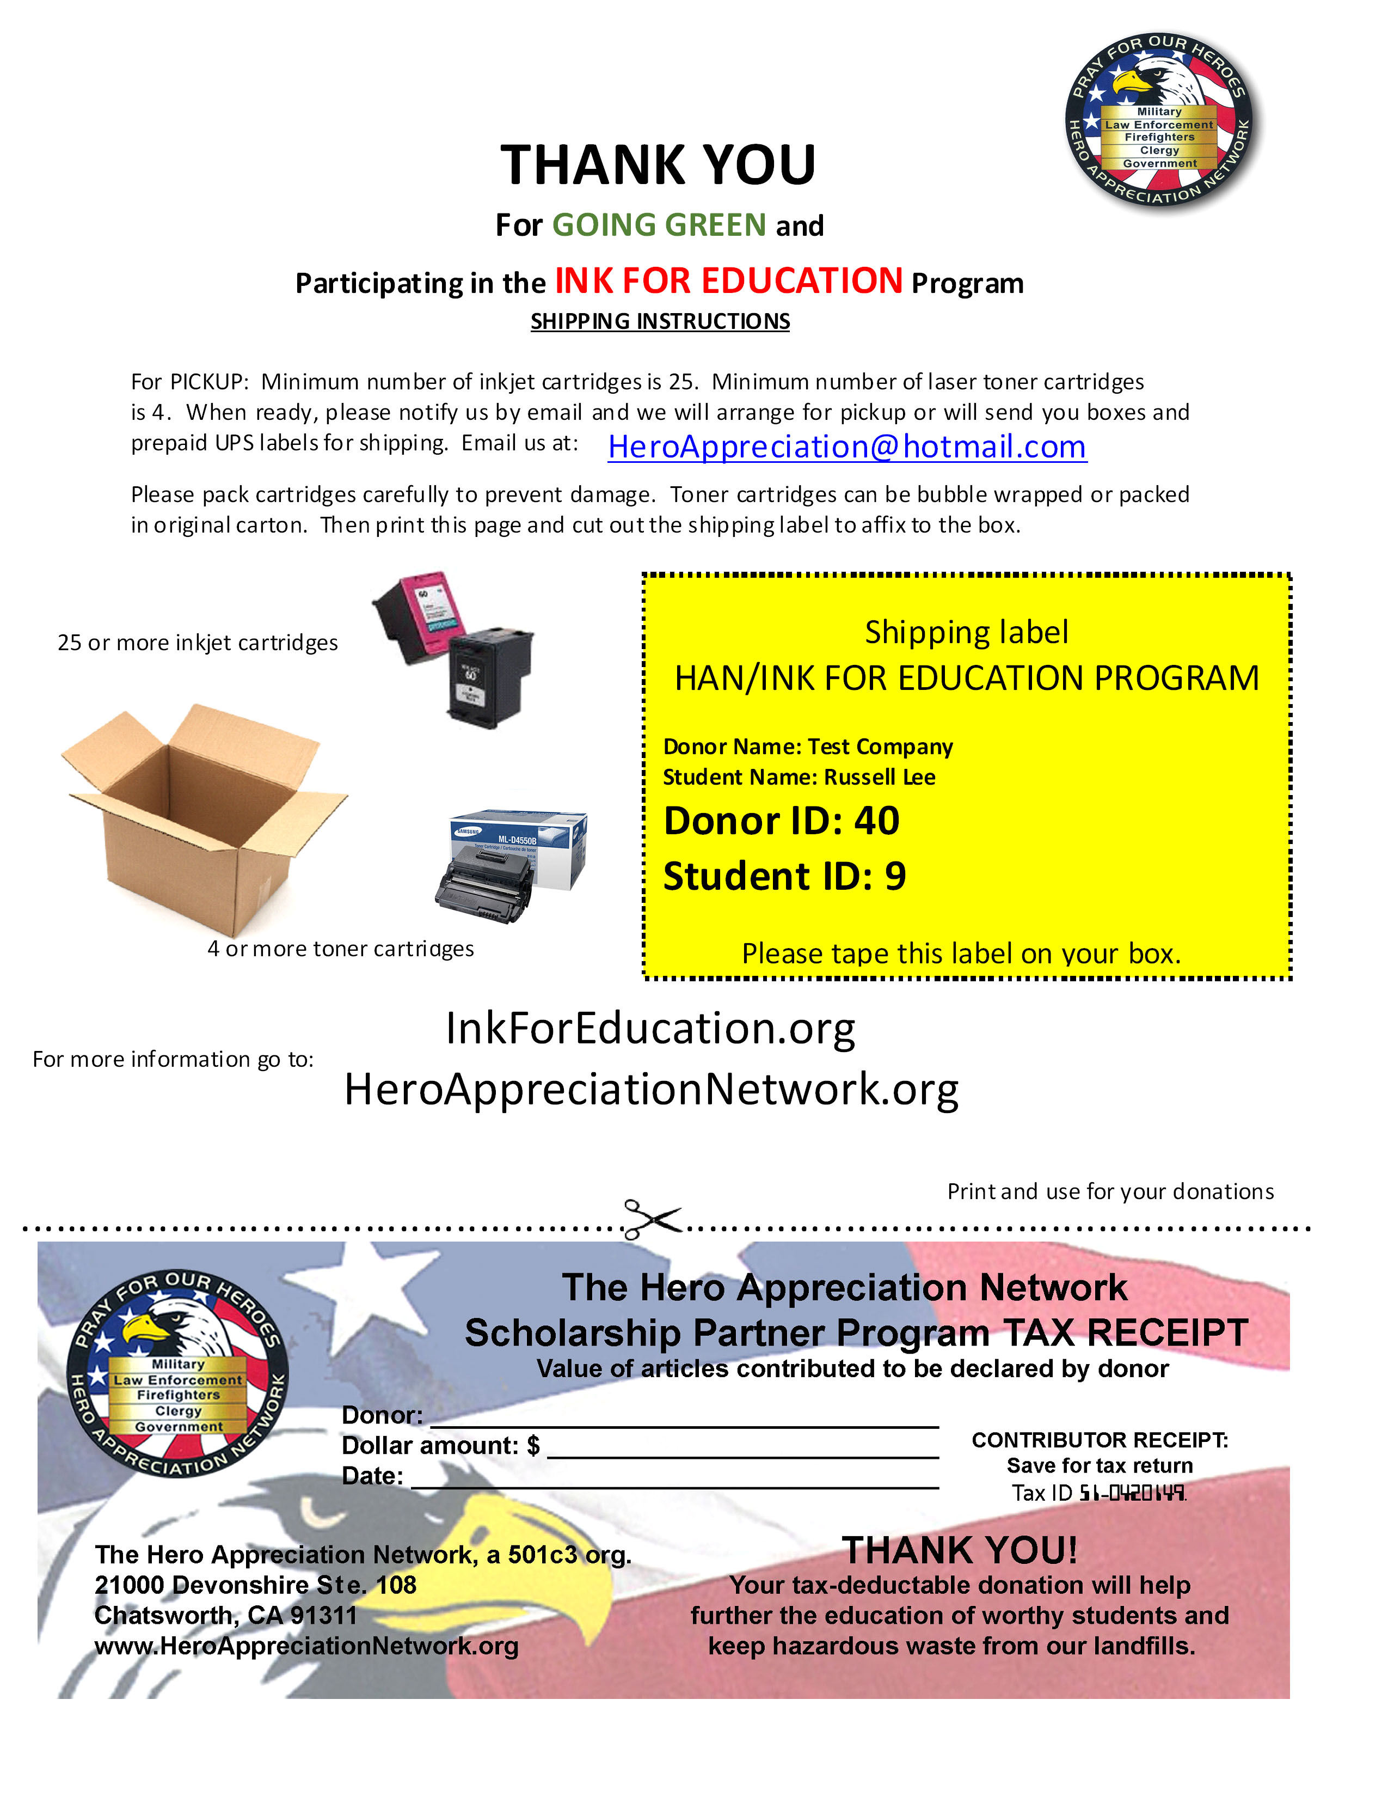

Introduction Letter



Thank You Letter/Tax Receipt

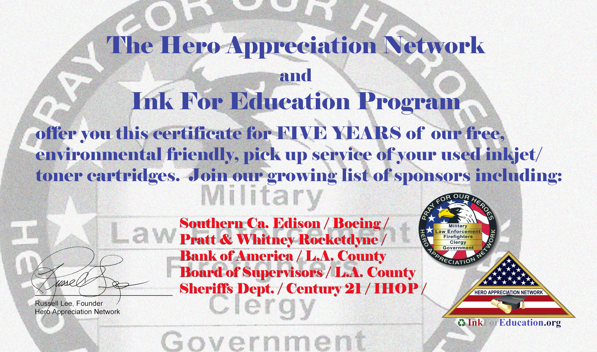
Business Identification Card

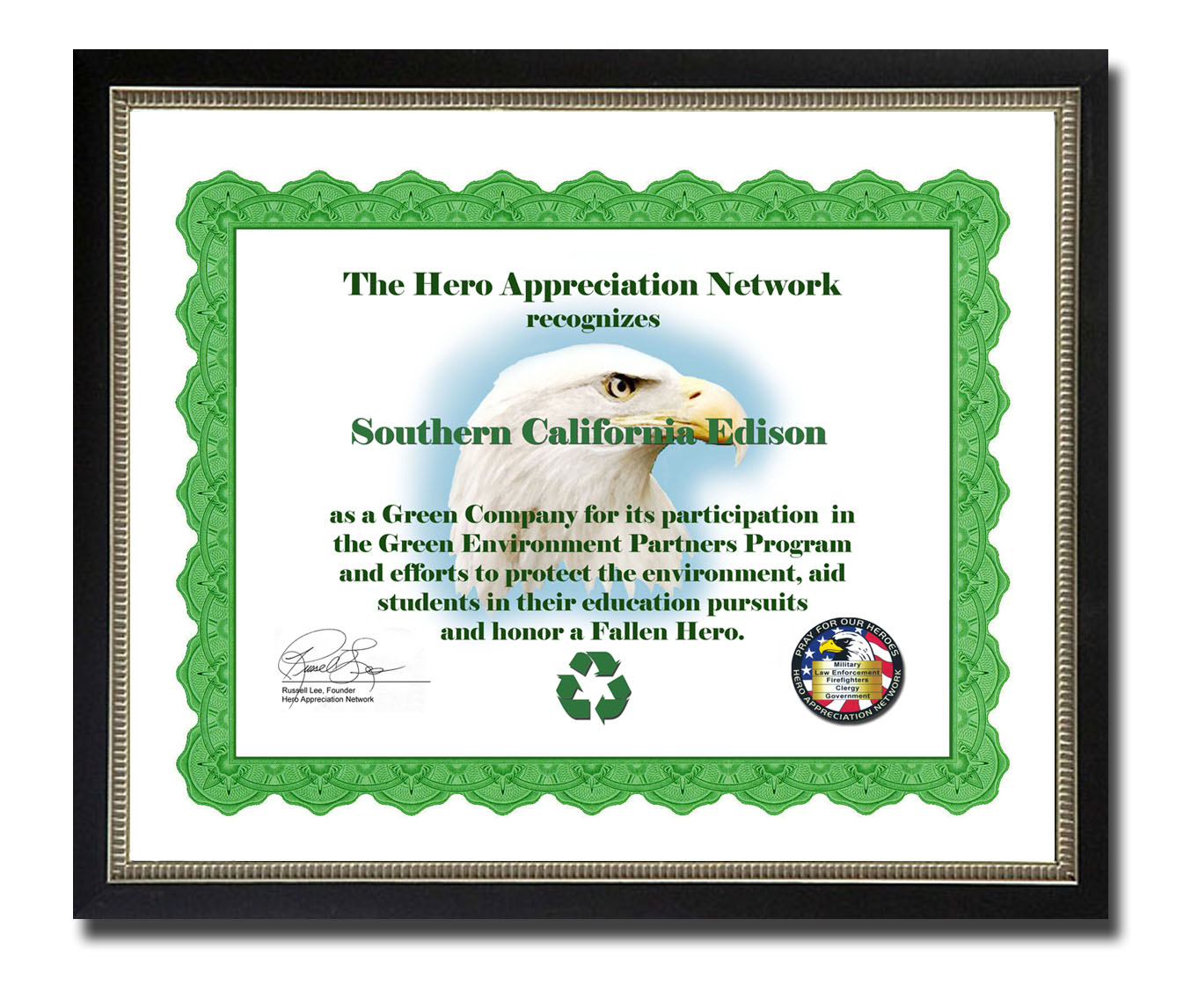

Five Year FREE Pickup Service Certificate

“Green Company” Certificate
Of Recognition

MATERIALS AND SERVICES AVAILABLE TO IFE PARTICIPANTS
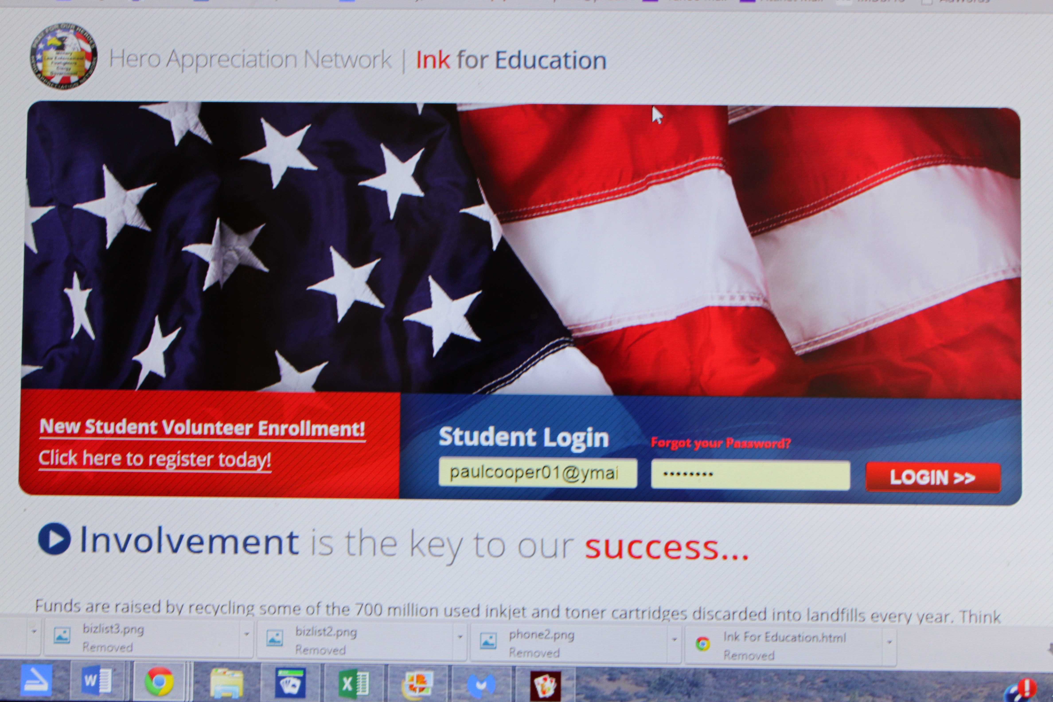

Access to the IFE state of the art website.

And extensive online training videos.


Member
Personal Biz Cards

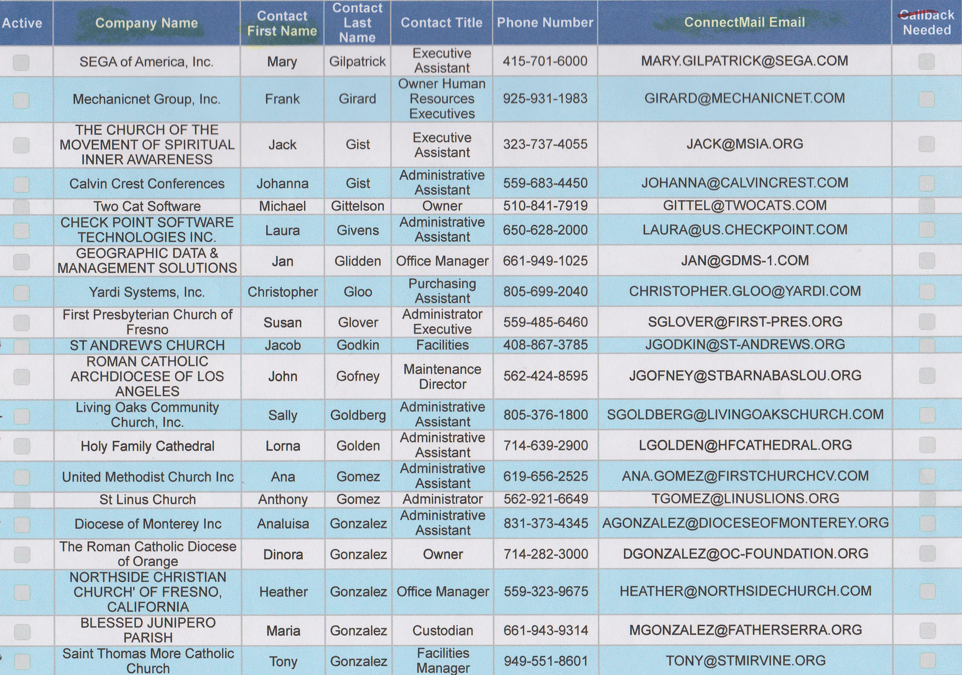

Business leads from our 2.2 million leads
data base at no cost to the member.
(Leads are a valuable resource costing
LEADS
IFE thousands of dollars.)



And an online account the member can
monitor 24/7

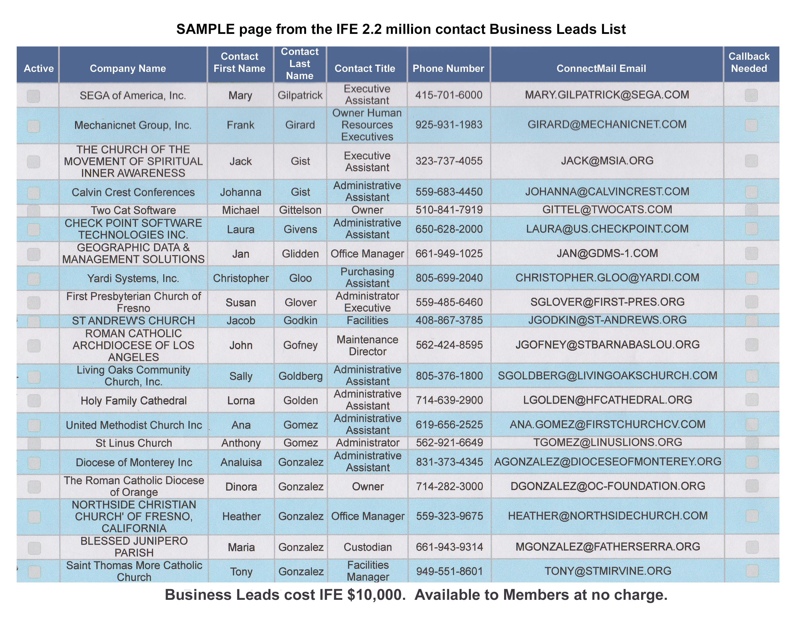
SAMPLE page from the IFE 2.2 million contact Business Leads List
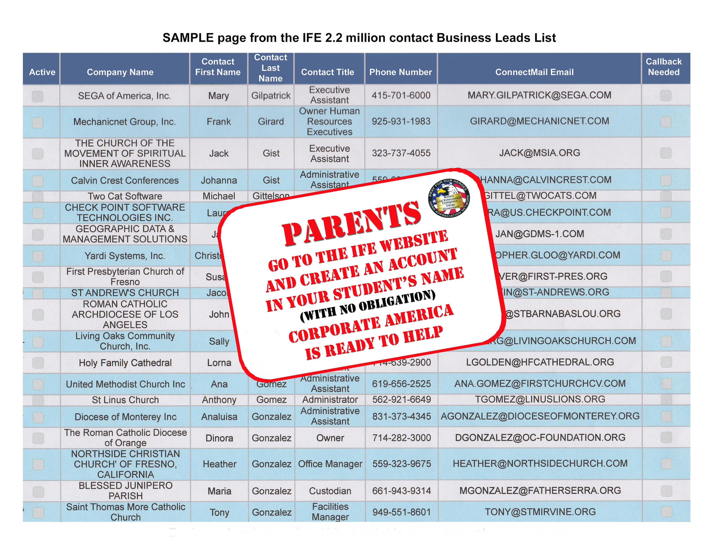



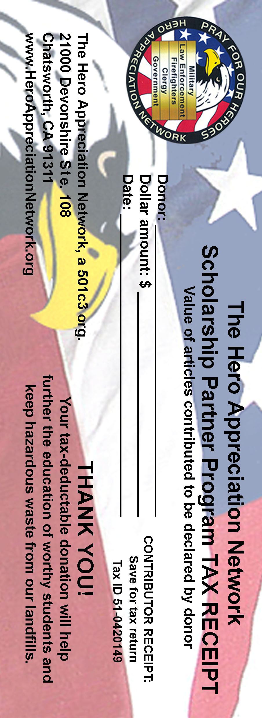

HOW ANYONE CAN HELP


As stated earlier, the Hero Appreciation Network was created to honor and pray for American Fallen Heroes from the ranks of our military, law enforcement and firefighters.

When you pray for these gallant individuals, please include a prayer for any or all of the youth today seeking relief from the cost of their higher education.

Pray for their education financial success!

If you would like the name of a specific individual in the IFE Program today for who’s success you can pray, contact us at www.HeroAppreciationNetwork.org and ask.



